**Assisted Practice: 3.3 Launch Instances in a Placement Group**

This section will guide you to:

* Launch an instance in a placement group

This lab has three subsections, namely:

3.3.1 Creating a placement group

3.3.2 Launching an instance in the placement group

3.3.3 Pushing the files to GitHub repositories

**Step 3.3.1:** Creating a placement group

* Click on *Create Placement Group*

# 

* Provide a name and strategy

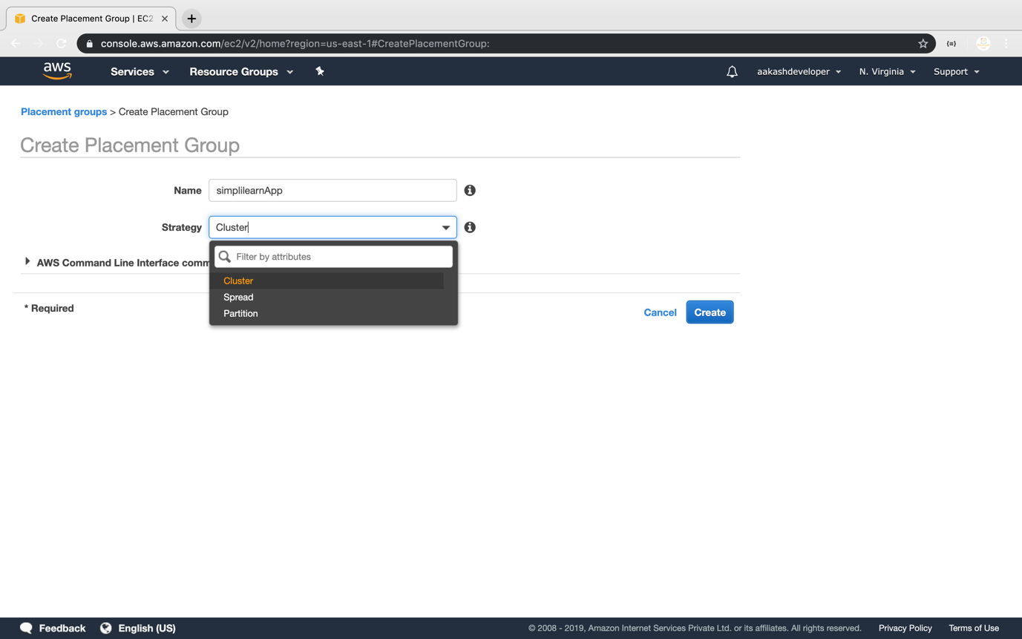

**Step 3.3.2:** Launching an instance in the placement group

* Launch the new EC2 instance

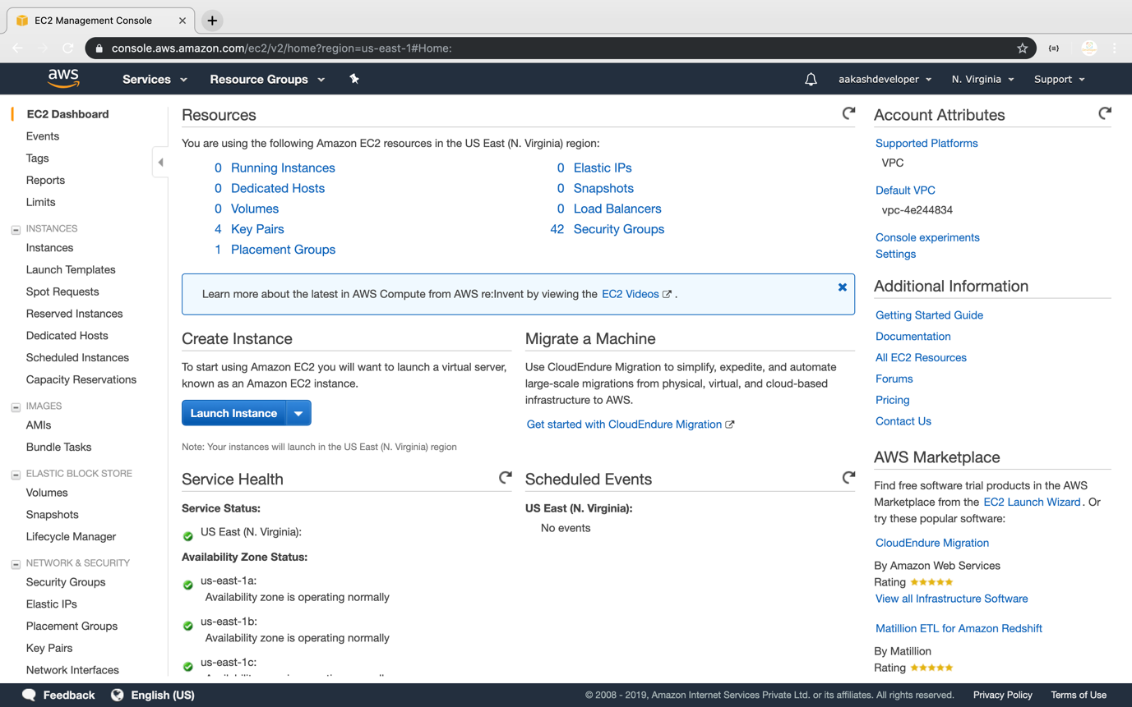

* Select the placement group

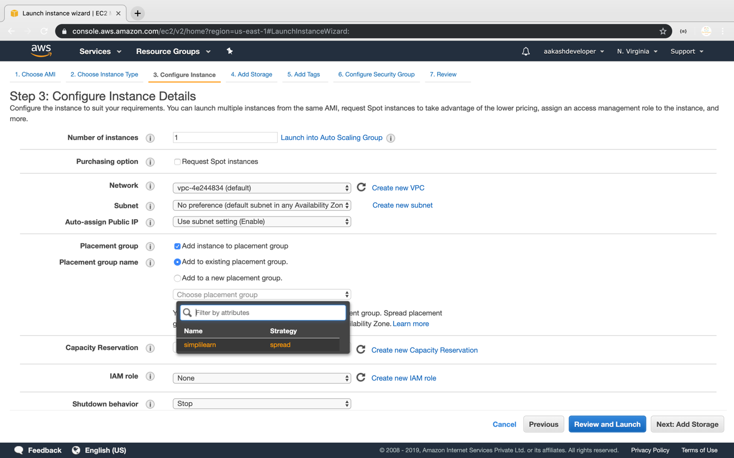

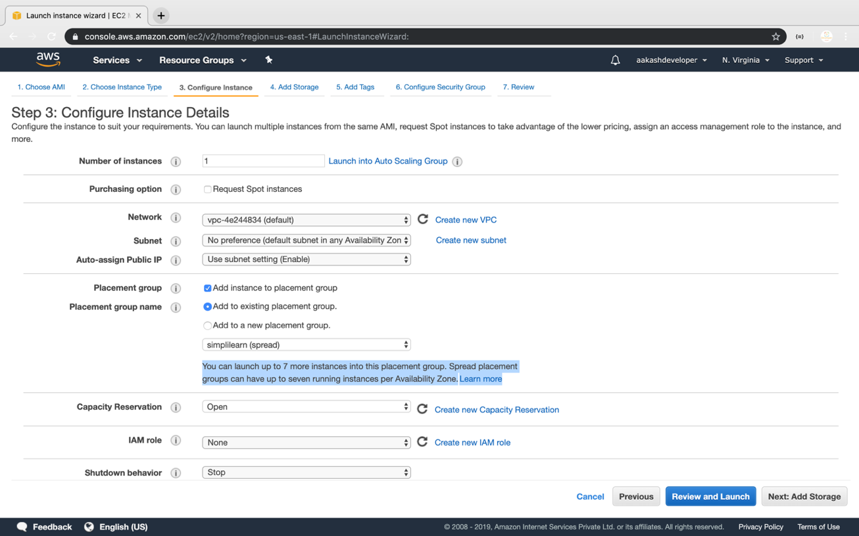

* Verify the placement group of the instance

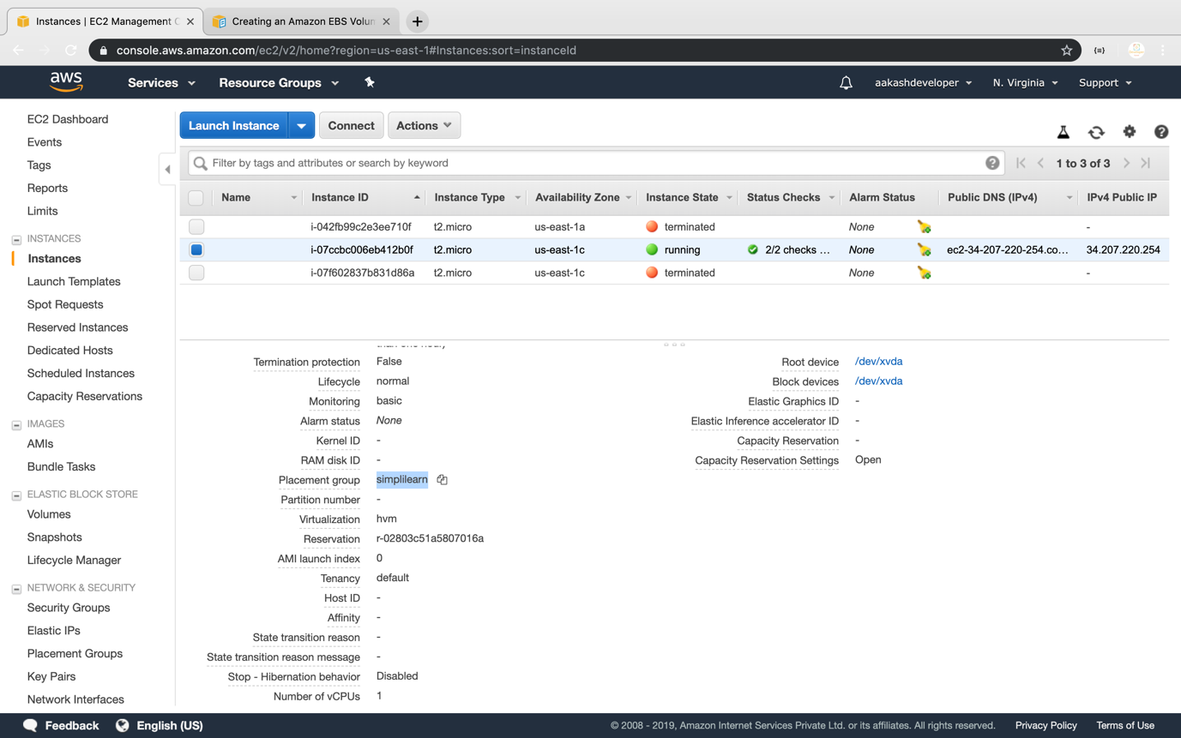

**Step 3.3.3:** Pushing the code to your GitHub repositories

* Open your command prompt and navigate to the folder where you have created your files.

**cd <folder path>**

* Initialize your repository using the following command:

**git init**

* Add all the files to your git repository using the following command:

**git add .**

* Commit the changes using the following command:

**git commit . -m “Changes have been committed.”**

* Push the files to the folder you initially created using the following command:

**git push -u origin master**